**Student Management System Using Salesforce CRM**

**Phase 1: Problem Understanding & Industry Analysis**

**1. Requirement Gathering**

Educational institutions require a system to manage student details, course enrollments, attendance, grades, and fees in a centralized manner. The requirements were gathered from administrators, teachers, and students to identify challenges in manual management.

**2. Stakeholder Analysis**

* **Students** – Need easy enrollment, grade tracking, and fee updates.
* **Teachers** – Need to record attendance, manage grades, and monitor performance.
* **Administrators** – Require centralized control over student data, reporting, and fee collection.
* **Parents/Guardians (Future)** – Require visibility into student performance and attendance.

**3. Business Process Mapping**

* **Student Admission** → Creation of student record.
* **Course Enrollment** → Mapping students to multiple courses.
* **Attendance Tracking** → Daily attendance marking per course.
* **Grade Management** → Entering marks and calculating GPA.
* **Fee Management** → Recording payments, balances, and due alerts.
* **Reporting & Analytics** → Generating performance, fee, and attendance reports.

**4. Industry-specific Use Case Analysis**

* Current systems in schools and colleges rely on **spreadsheets/manual records**, causing redundancy and errors.
* Industry trend is shifting to **cloud-based CRMs** like Salesforce for data accuracy and accessibility.
* Similar use cases:
  + University student portals.
  + Training centers managing course enrollments.
  + Coaching institutes tracking performance.

**5. AppExchange Exploration**

* Explored Salesforce **AppExchange** solutions for education management.
* Found apps like:
  + **Salesforce Education Cloud** – Comprehensive education CRM.
  + **Student Success Hub** – Focused on K-12 student outcomes.
  + **Attendance & Fee Management Apps** – Useful but often paid solutions.
* Decided to **build a custom Student Management System** tailored for specific institutional needs instead of relying fully on prebuilt paid apps.

**Phase 2: Org Setup & Configuration – Student Management System**

**1. Salesforce Edition**

* **Developer Edition** (Dev Org) used for project setup.

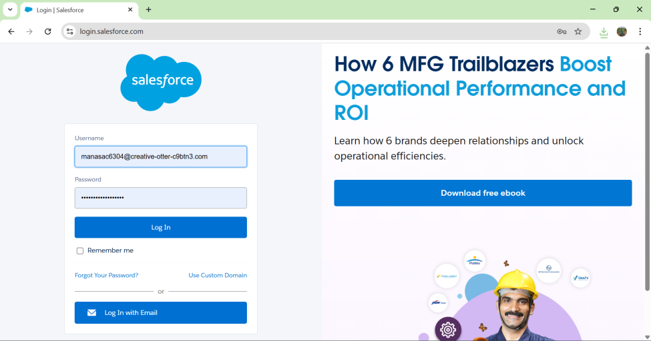

**2. Company Profile Setup**

* Configured **Institution Name, Address, Default Time Zone, Currency, and Locale**.

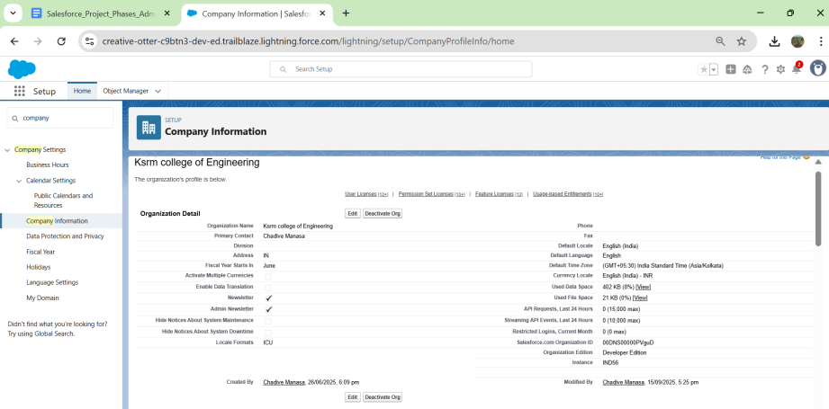

**3. Business Hours & Holidays**

* Defined **Standard Business Hours** (9 AM – 6 PM, Mon–Sat).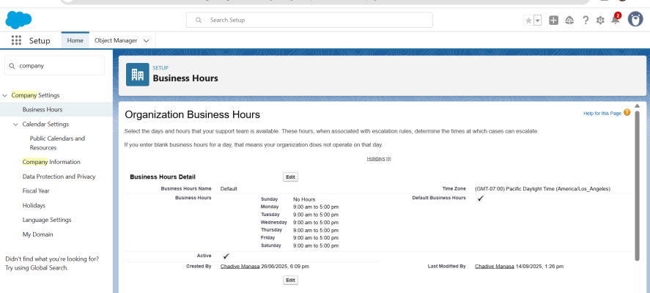
* Added **holidays** (e.g., Independence Day, New Year).

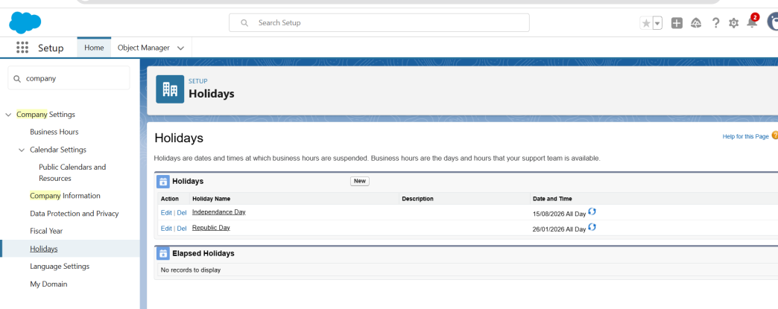

**4. Fiscal Year Settings**

* Configured **Standard Fiscal Year** (Jan–Dec).

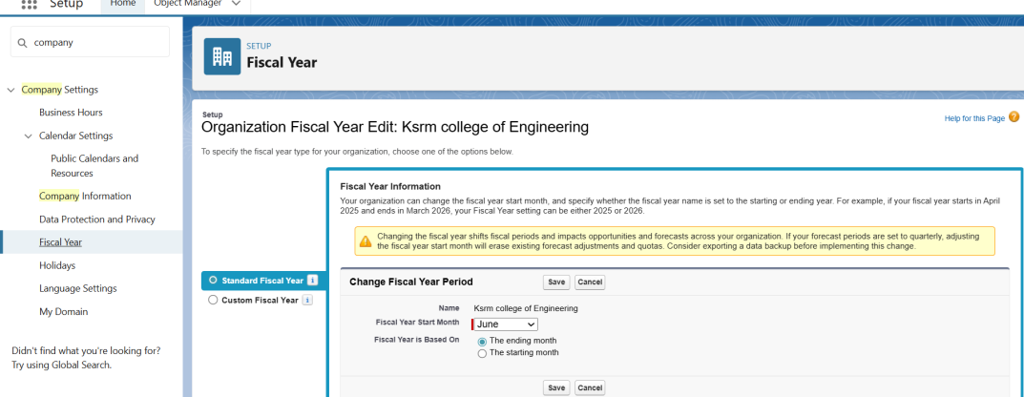

**5. User Setup & Licenses**

* Created sample users with **Salesforce licenses**:
  + **System Administrator** – Full access.
  + **Faculty User** – Limited teaching access.
  + **Student User** – Read-only/student data access.

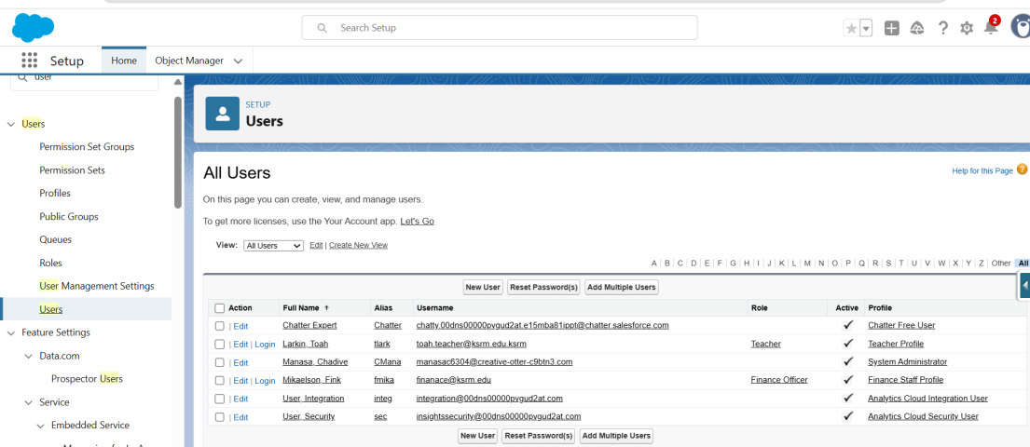

**6. Profiles**

* Created/Modified Profiles:
  + **System Administrator** (default full access).
* 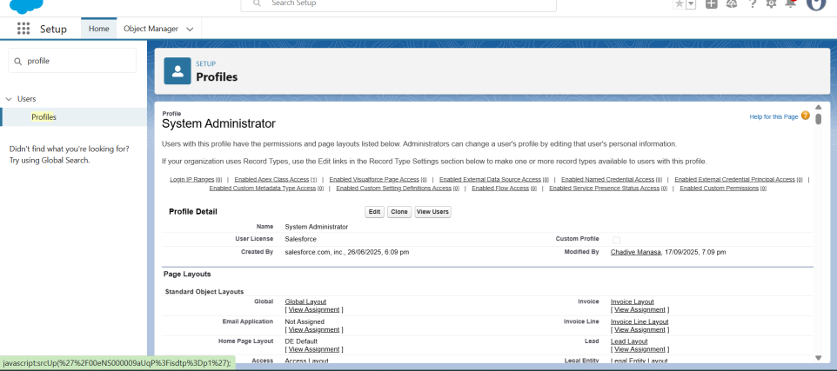
  + **Teacher Profile** – Access to Students, Courses, Attendance, Grades.

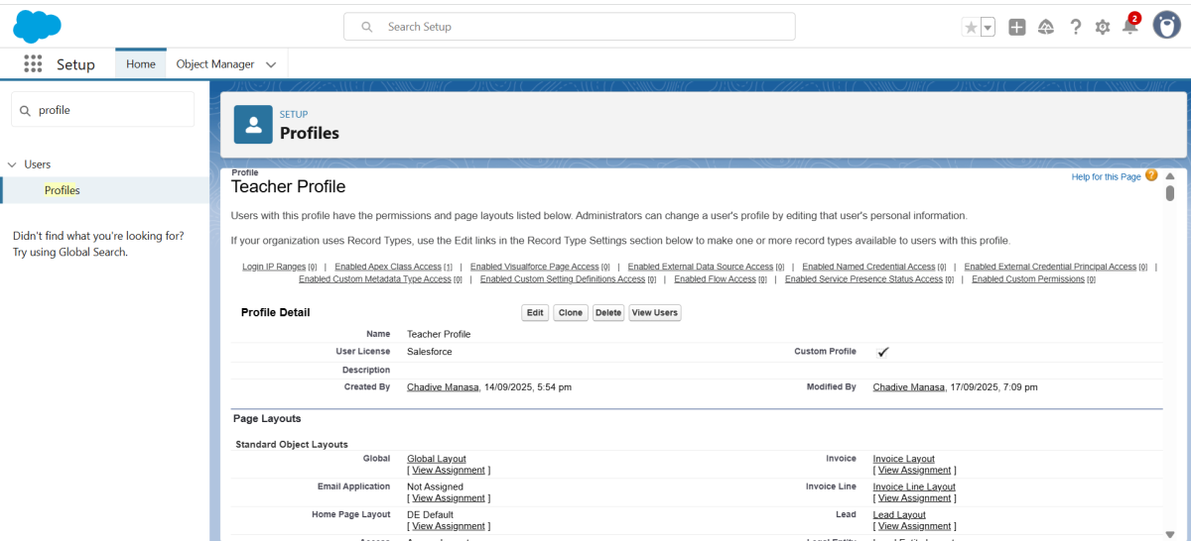

* + **Finance Profile** – Access to Fees object.

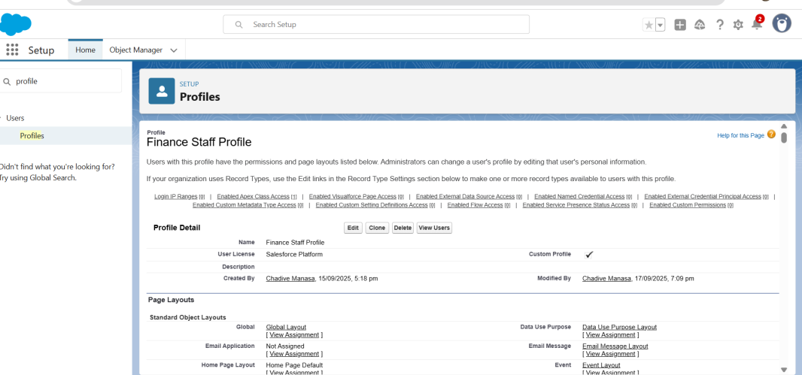

**7. Roles**

* Defined Role Hierarchy:
  + **Principal (Top Role)**
    - HOD
    - Finance Officer
    - 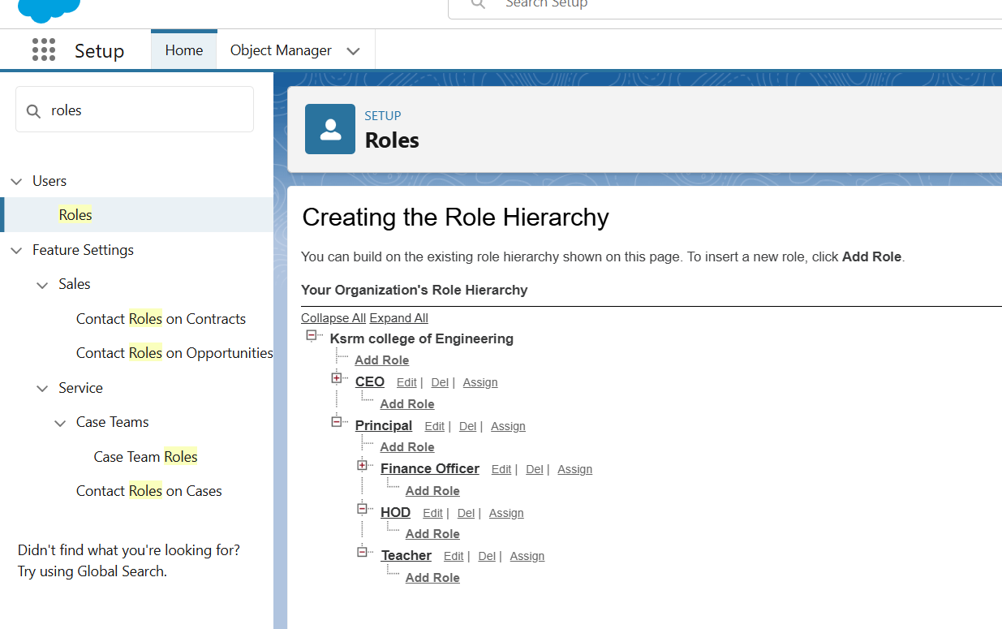Teacher

**8**

**8.Permission Sets**

* Created Permission Sets for additional access:
  + **Report Access** – Extra reporting permissions.
  + **Fee Management Access** – Extended access to Fees object.

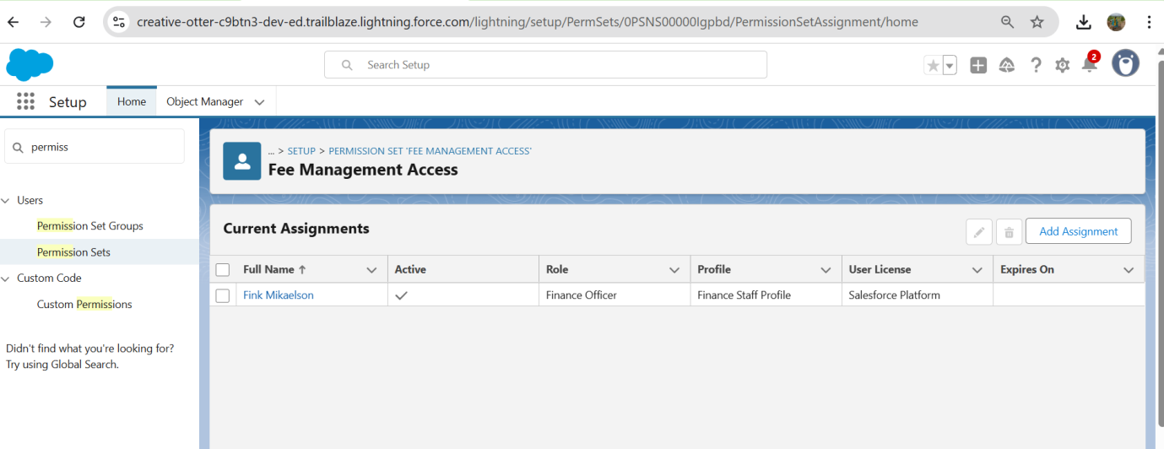

**9. Objects Created**

* **Student (Custom Object)** – Manage student details.
* **Course (Custom Object)** – Store course information.
* **Enrollment (Junction Object)** – Relationship between Student & Course.
* **Attendance (Custom Object)** – Track daily student attendance.
* **Grades (Custom Object)** – Store marks, grades, GPA.
* **Fees (Custom Object)** – Manage payments and pending balances.

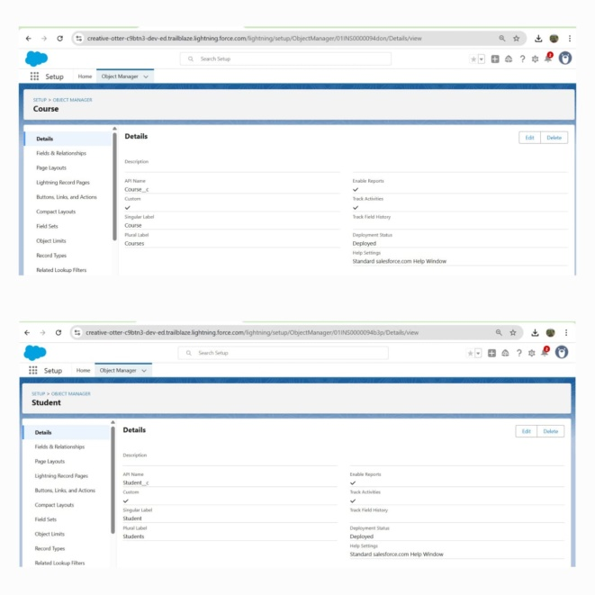

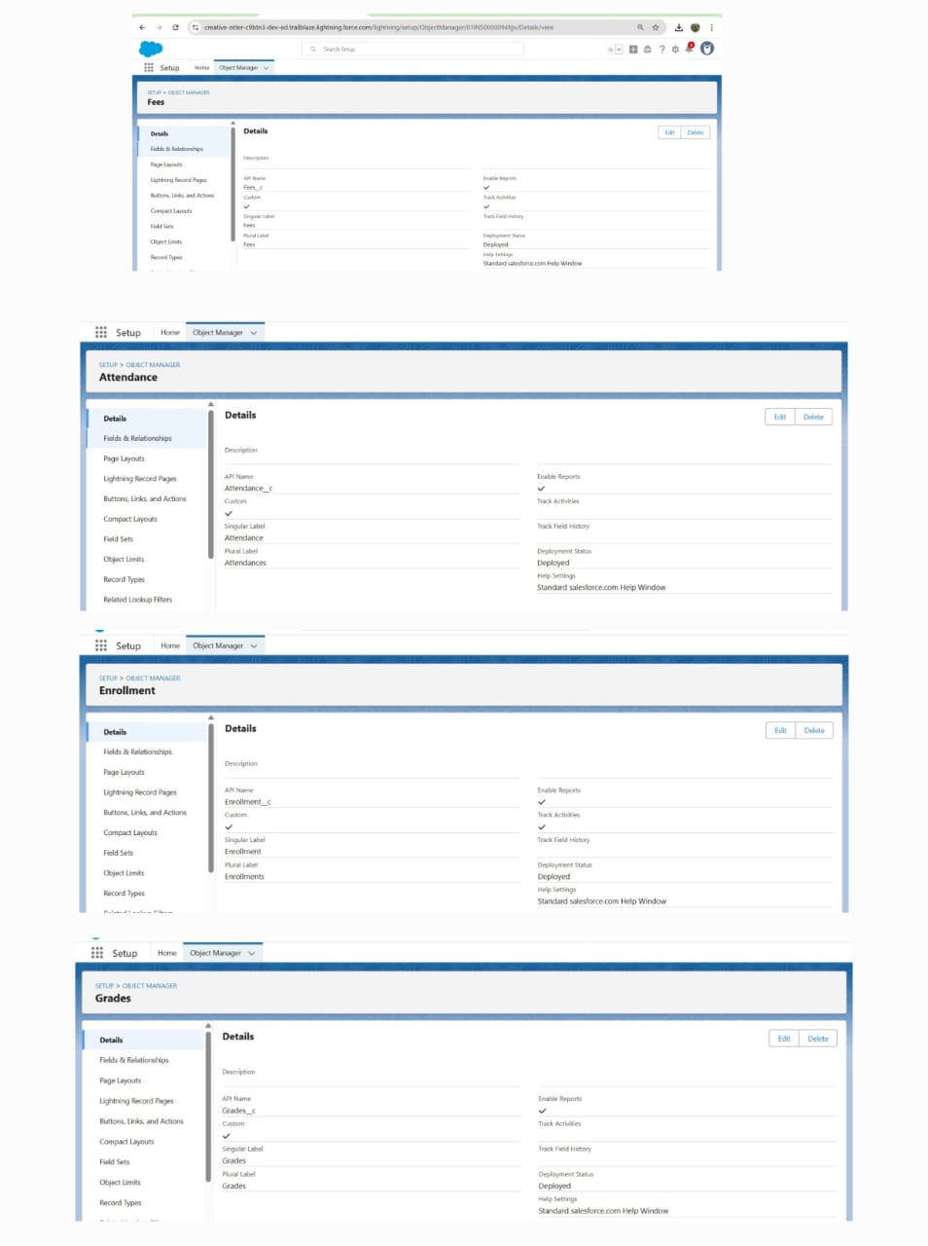

**10. OWD (Org-Wide Defaults)**

* Student → Private
* Course → Public Read Only
* Enrollment → Private
* Attendance → Private
* Grades → Private
* Fees → Private

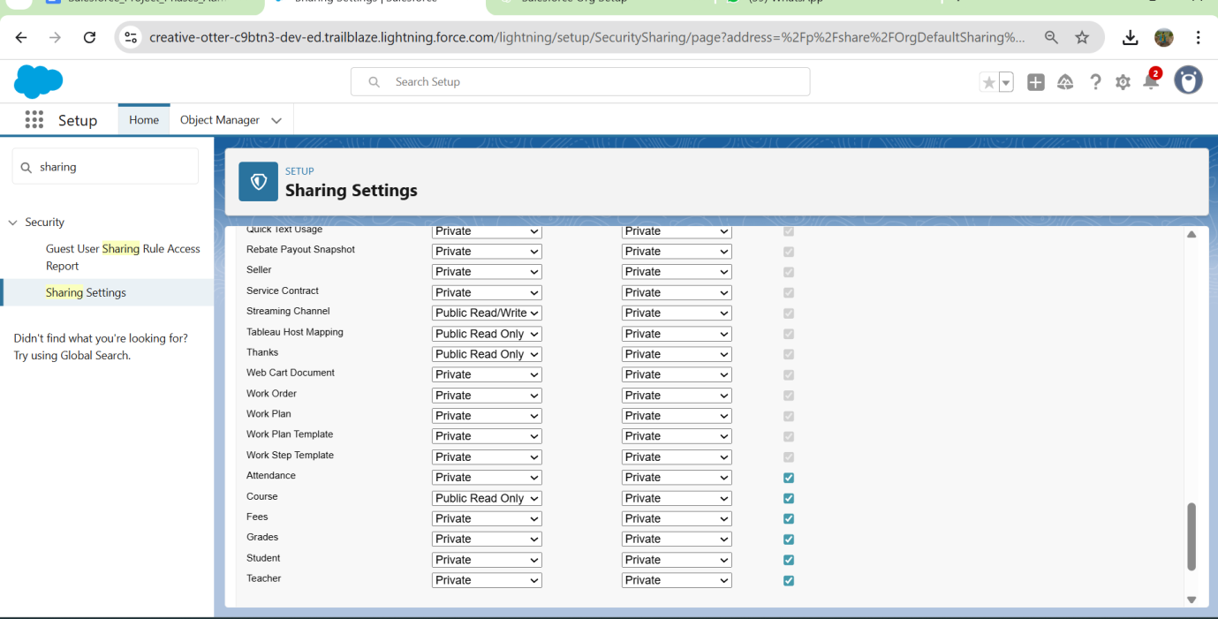

**11. Sharing Rules**

* Shared **Courses** with all Faculty.
* Shared **Student Records** read-only with Faculty (except Finance objects).
* Finance users granted access to **Fees object**. 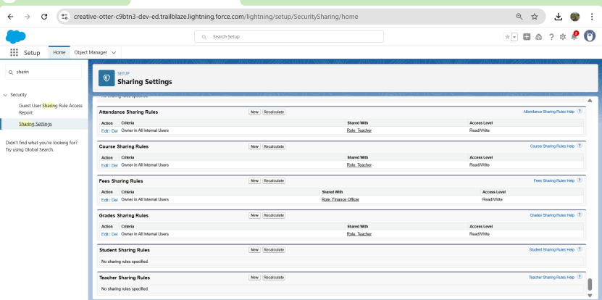

**12. Login Access Policies**

* Enabled **Administrators Can Log in as Any User**.
* Configured **Trusted IP Ranges** for secure login.

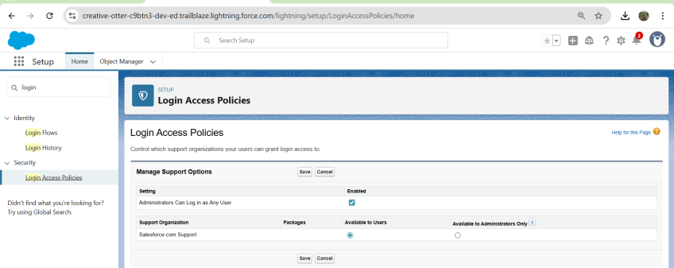

**13. Dev Org Setup**

* Enabled **Dev Hub** in Developer Org.
* Connected CLI:
* sf org login web --set-default-dev-hub --alias DevHub

**14. Sandbox Usage**

* **Not available** in Developer Edition.
* Documented sandbox usage for real-world projects (Dev, Test, UAT).

**15. Deployment Basics**

* Practiced deployment commands:
* sf project retrieve start --manifest manifest/package.xml -o DevHub
* sf project deploy start --target-org ScratchOrg
* Source code and configuration stored in **GitHub repo** for version control.